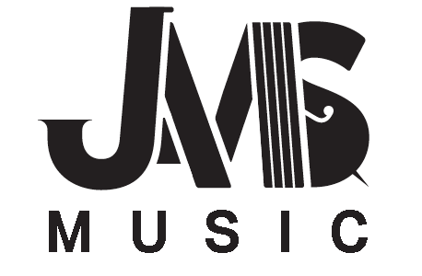**JANE ADDAMS MUSIC CALENDAR**

**2015-2016**

Updated 3/15/2016

|  |  |
| --- | --- |
| OCTOBER  7 Parent Meeting (6:30) & FOJAM Board Meeting (7pm)  16 Overnight Orchestra Camp at JAMS  16 Senior Jazz Overnight  24 Edmonds Jazz Symposium *(SJ)*  NOVEMBER  4 Parent Meeting (6:30) & FOJAM Board Meeting (7pm)  13 Senior Band Overnight  18 Orchestra Summit with Garfield Orchestra  21 Mill Creek Jazz Symposium *(SJ)*  DECEMBER  9 FOJAM Board Meeting (7pm)  10 Orchestra & Choir Winter Concert  15 Band Winter Concert  DEC. 21 – JAN. 1: WINTER BREAK  JANUARY  6 FOJAM Board Meeting (7pm) (*6:30 parent meeting cancelled*)  8 Middle School Choir Festival *(Ch)* @ Eckstein  12 Outreach vertical choral concert (Middle and High schools) at Roosevelt HS (7 PM)  13 Winter Jazz Night at Nathan Hale Performing Arts Center (7pm)  28 Clark College Jazz Festival *(SJ)*  FEBRUARY  3 Parent Meeting (6:30) & FOJAM Board Meeting (7pm)  4 CANCELLED: ~~Music-a-Thon “Month of Music” Kickoff~~  8 Pacific NW Band Festival at UW *(SB)*  18 Feeder Elementary School concert (6:30 call- *Intermediate ensembles*)  FEB. 15-16 MID-WINTER BREAK  25--28 Lionel Hampton Intl. Jazz Festival *(SJ)* | MARCH  *National Music in Schools Month*  2 Parent Meeting (6:30) & FOJAM Board Meeting (7pm)  4 Junior Band “Team Friday”  11 Western Washington University *(JO, SO, ChO)*  17 Orchestra & Choir Spring Concert  18 Intermediate Band “Team Friday”  24 Band Concert  25 SPS Band Festival *(JB)*  25 Jane Addams/Hamilton Orchestra Summit (*IO*)    APRIL  6 Parent Meeting (6:30-for Silverwood) & FOJAM Board Meeting (7pm)  APRIL 11 – 15: SPRING BREAK  8-10 Next Generation Jazz Festival (Monterey, CA) *(SJ)*  MAY  4 FOJAM Board Meeting (7pm)  8 Bellevue HS Jazz Festival (JJ, SJ)  20-22 Music in the Parks Festival – Silverwood  *(SB, ChO, SO, Intermediate Choir)*  28 Northwest Folklife Festival *(ChO)*  JUNE  1 Spring Jazz Concert *(SJ, JJ)*  2 Entering 6th Graders Ice Cream Social  *(SJ Combos or Chamber Orchestra)*  4 Music in the Parks Festival – Wild Waves   *(JB, JO, JJ)*  7 End of the year Orchestra/Choir Concert  8 FOJAM Board Meeting (7pm)  9 End of the year Band Concert  16 Jazz Concert at Nathan Hale HS (location preliminary) (*JJ, SJ)*  19 Royal Room concert (preliminary) (*BJ, JJ, SJ)*  *TBD* 8th Grade Promotion *(Orchestra or Jazz)*  *TBD*SUMMER MUSIC AT JAMS (incoming 6th graders) |

**Key:** *JO* **(***Junior Orchestra), JB (Junior Band), IO (Intermediate Orchestra), SO (Senior Orchestra), SB (Senior Band), ChO (Chamber Orchestra), SJ (Sr. Jazz), Ch (Choir), JJ (Jr. Jazz).* **Concerts start at 7:00 p.m. • Students need to arrive by 6:30 p.m.**  
***\**All Jazz Concerts will be held at Nathan Hale High School**   
***DATES CAN CHANGE, ALWAYS CHECK*** [www.fojam.org](http://www.fojam.org)