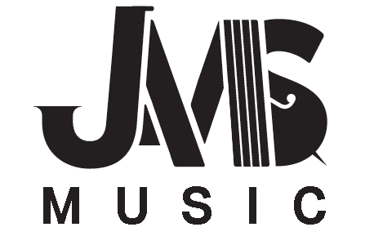

Dear JAMS Jazz Families,

Thank you for your interest in registering your child(ren) for Jazz After School! This year, we will have two groups:

**Beginning Jazz** Mondays & Wednesdays from 2:30-4:30. This group, under the direction of the fantastic Colin Pulkrabek, is for students who have at least one year of playing experience but are new to jazz. (Intermediate Band members will be in this group, unless they have successfully auditioned out of it.)

**Junior Jazz** Tuesdays & Thursdays from 2:30-4:30. This group is for students who have successfully completed a year of jazz band, or who have permission from Deb. Under the direction of the incomparable Dan Rowe.

There will be three sessions of Jazz After School during the year. Session 2 will run from January 4 through March 4. The cost this session is $100. This includes tuition and materials (music!). No JAMS music student will ever be denied participation due to financial circumstances. Scholarships are available.

Please complete the student information form below and return with your check **payable to FOJAM.**

**Student Name: _______________________________________________**

**Instrument: ____________________________ No. of Years Played: ___________________**

**Private Lessons? Y/N**

**Please circle your current music class*:**

**Band: Beginning Intermediate Junior Senior Sr Jazz**

**Orchestra: Beginning Intermediate Junior Senior Chamber**

*Guitarists are not required to participate in a band/orchestra class. Please see Deb for class placement.

**Parent Name: __________________________________________**

**Email: ____________________________**

**Phone: ____________________________ text? Y/N**